# Finding Trigonometric Functions Using the Unit Circle

A **unit circle** is centered at the origin $(0,0)$ with radius 1. The angle (in radians) that $t$ intercepts forms an arc of length $s$. Using the formula $s=rt$, and knowing that $r=1$, we see that for a unit circle, $s=t$.

For any angle $t$, we can label the intersection of the terminal side and the unit circle as by its coordinates $(x,y)$. The coordinates $x$ and $y$ will be the outputs of the trigonometric functions $f\left(t\right)=\cos{t}$ and $f\left(t\right)=\sin{t}$, respectively. This means $x=\cos{t}$ and $y=\sin{t}$.

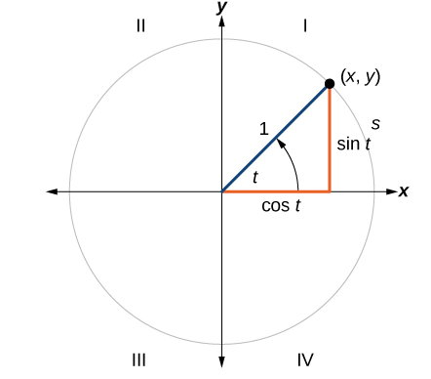

## Defining Sine and Cosine Functions from the Unit Circle

If $t$ is a real number and a point $(x,y)$ on the unit circle corresponds to a central angle $t$, then

$$\cos{t}=x$$

$$\sin{t}=y$$

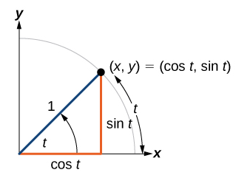

Examples

1. A certain angle $t$ corresponds to a point on the unit circle at $\left(-\frac{\sqrt{2}}{2},\frac{\sqrt{2}}{2}\right)$, as shown below. Find $\cos{t}$ and $\sin{t}$.

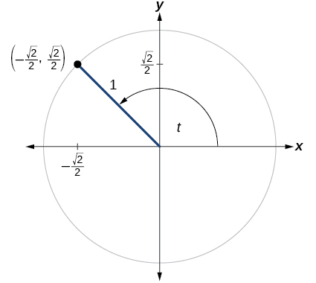

1. Find $\cos{t}$ and $\sin{t}$.

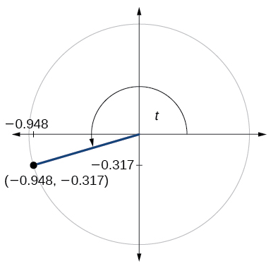

For 3 – 4, use the given sign of the sine and cosine functions to find the quadrant in which the terminal point determined by $t$ lies.

1. $\sin{t}<0$ and $\cos{t}<0$
2. $\sin{t}>0$ and $\cos{t}<0$

For 5 – 8, find the exact value of each trigonometric function.



$\sin{90°}$

$\cos{\frac{π}{3}}$

$\sin{π}$

## The Pythagorean Identity

Now that we can define sine and cosine, we will learn how they relate to each other and the unit circle. Recall that the equation for the unit circle is $x^{2}+y^{2}=1$. Because $x=\cos{t}$ and $y=\sin{t}$, we can substitute for $x$ and $y$ to get $\cos^{2}{t}+\sin^{2}{t}=1$.

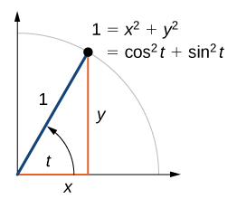

The **Pythagorean Identity** states that, for any real number $t$,

$${\text{cos} }^{2}t+{\text{sin}}^{2}t=1$$

We can use the Pythagorean Identity to find the cosine of an angle if we know the sine, or vice versa. However, because the equation yields two solutions, we need additional knowledge of the angle to choose the solution with the correct sign. If we know the quadrant where the angle is, we can easily choose the correct solution.

Given the sine (or cosine) of some angle $t$ and its quadrant location, find the cosine (or sine) of by

1. Substitute the known value for $\sin{t}$ (or $\cos{t}$) into the Pythagorean Identity.

2. Solve for (or ).

3. Choose the solution with the appropriate sign for the $x$-values (or $y$-values if solving for $\sin{t}$) in the quadrant where $t$ is located.

Examples

1. If $\sin{t}=\frac{3}{7}$ and $t$ is in the second quadrant, find $\cos{(t)}$.
2. If $\cos{t}=\frac{24}{25}$ and $t$ is in the fourth quadrant, find $\sin{(t})$.
3. Find the coordinates of the point on a circle with radius 15 corresponding to an angle of $220°$.

# Finding Reference Angles

For any given angle in the first quadrant, there is an angle in the second quadrant with the same sine value. Because the sine value is the $y$-coordinate on the unit circle, the other angle with the same sine will share the same $y$-value but have the opposite $x$-value. Therefore, its cosine value will be the opposite of the first angle’s cosine value.

Likewise, there will be an angle in the fourth quadrant with the same cosine as the original angle. The angle with the same cosine will share the same $x$-value but will have the opposite $y$-value. Therefore, it’s sine value will be the opposite of the original angle’s sine value.

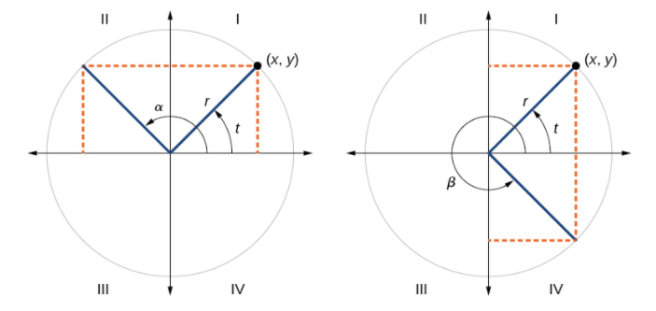

An angle’s **reference angle** is the acute angle, $t$, formed by the terminal side of the angle $t$ and the horizontal axis. A reference angle is always an angle between $0°$ and $90°$, or $0$ and $\frac{π}{2}$ radians. For any angle in quadrants II, III, or IV, there is a reference angle in quadrant I.

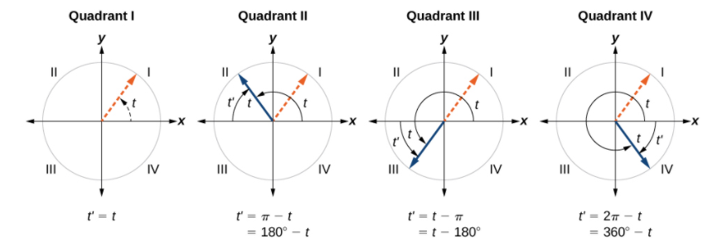

Given an angle between $0$ and $2π$, we can find the reference angle.

An angle in the first quadrant is its own reference angle.

For an angle in the second or third quadrant, the reference angle is $\left|π-t\right|$ or $\left|180°-t\right|$.

For an angle in the fourth quadrant, the reference angle is $2π-t$ or $360°-t$.

If an angle is less than $0$ or greater than $2π$, add or subtract $2π$ as many times as needed to find an equivalent angle between $0$ and $2π$.

Examples

1. Find the reference angle of $225°$.
2. Find the reference angle of $\frac{5π}{3}$.

# Using Reference Angles

We can find the cosine and sine of any angle in any quadrant if we know the cosine or sine of its reference angle.

## Using Reference Angles to Find Cosine and Sine

Angles have cosines and sines with the same absolute value as their reference angles. The sign (positive or negative) can be determined from the quadrant of the angle.

Given an angle in standard position, find the reference angle, and the cosine and since of the original angle.

1. Measure the angle between the terminal side of the given angle and the horizontal axis (that is the reference angle).

2. Determine the values of the cosine and sine of the reference angle.

3. Give the cosine the same sign as the $x$-values in the quadrant of the original angle.

4. Give the sine the same sign as the $y$-values in the quadrant of the original angle.

Examples

1. Use the reference angle of $315°$ to find $\cos{(315°)}$ and $\sin{(315°)}$.
2. Use the reference angle of $-\frac{π}{6}$ to find $\cos\left(-\frac{π}{6}\right)$ and $\sin\left(-\frac{π}{6}\right)$.

For 3 and 4, find the reference angle, the quadrant of the terminal side, and the sine and cosine of each angle. If the angle is not one of the angles on the unit circle, use a calculator and round to three decimal places.

$320°$

$-\frac{2π}{3}$

## Using Reference Angles to Find Coordinates

If you know all the special angles in the first quadrant, you can use symmetry and reference angles to fill in cosine and sine values for the rest of the special angles on the unit circle:

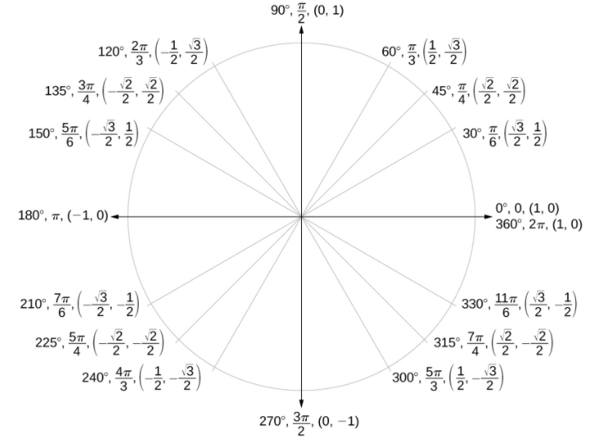

We can also use reference angles to find $(x,y)$ coordinates of any point on the unit circle, using what we know about reference angles along with the identities, $x=\cos{t}$ and $y=\sin{t}$.

Given the angle of a point on a circle and the radius of the circle, find the $(x,y)$ coordinates of the point.

1. Find the reference angle by measuring the smallest angle to the -axis.

2. Find the cosine and sine of the reference angle.

3. Determine the appropriate signs for $x$ and $y$ in the given quadrant.

Examples

1. Find the coordinates of the point on the unit circle at an angle of $\frac{7π}{6}$.
2. Find the coordinates of the point on the unit circle at an angle of $\frac{5π}{3}$.